# Introduction

Our way of life requests everything to be remote controlled. Apart from couple of things man has made his life automated. And why not! In the realm of development gadgets, life of individuals ought to be simpler subsequently to make life easier and helpful". Irrigation is the backbone for the farming industry and it should be adequate amount. Most of the percentage of water also get wasted due to lack of proper attention and management by farmer. Beside water wastage, farmers are compelled to waste their valuable time doing monotonous faming job i.e. watering plants. Manual irrigation brings many problems from water wastage to inadequate supply of water in farm.

To deal with this every individual farmer problem this project puts forward the solution that is nothing but “Automatic Irrigation System”. (Shah, 2015) This system controls and provide adequate amount of water which intern saves the greenery of the lawn and Farm. Actually, In the system Sensor (soil moisture) sense the moisture value in soil and microcontroller controls the water motor according to the soil moisture value and notifies the water motor sates by glowing blub insight and with SMS notification remotely.

# Aim and Objectives

## Aim

To develop an Arduino based smart Irrigation system thereby saving time & power for the farmer.

## Objectives

* Detect moisture of soil using soil moisture sensor.
* Operate water motor according to the soil moisture detected by the sensor.
* Notify the status of soil moisture and water motor to the individual through GSM Module remotely and locally indicate through on-sight light bulb.

# Justification for project

Irrigation is backbone for farming industry and the requirement of water for farm is high. As per the demand excessive amount of water gets wasted due to manual watering. Wrong water harvesting plan and improper maintenance creates scarcity of water.



Figure 1: Rich picture showing problem domain

Here in above picture, Famer ruin their valuable time and power watering the plants. If any system could control this, he could spend his time working on other stuffs instead of wasting his time watering his plants. Imagine the pain that individual’s have to watch each and every place and manually water all areas in the field.

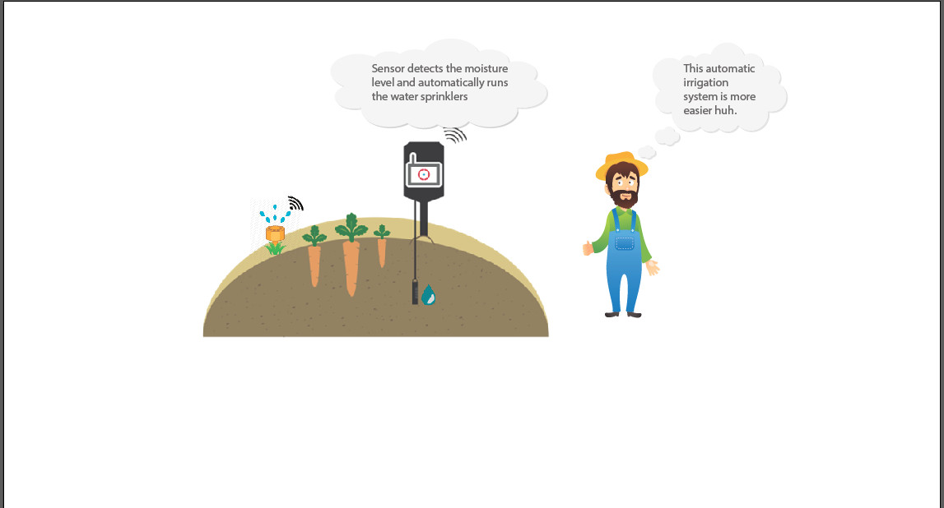

Figure 2: Rich picture showing solution

Look at the image above how happy this farmer seems to be right now. All the stuffs now are controlled automatically by smart Irrigation system. Here soil moisture sensor collects all information which is processed by microcontroller and action is handled using relay. The most monotonous part of cultivating is now handled by system and he will be notified for everything. (Upadhyay, 2015)

# Hardware Required

* *Arduino Uno*

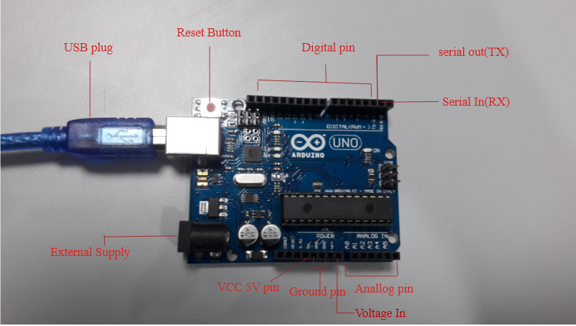

Figure 3: Arduino UNO as Microcontroller

* *Power (Battery 9v)*

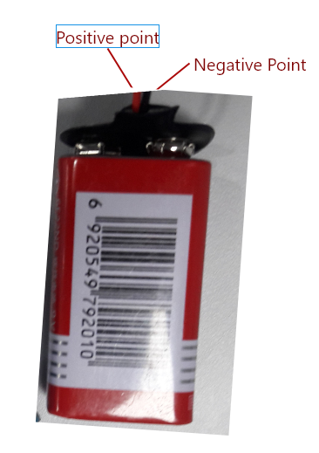

Figure 4: Power 9V battery to operate Water motor

* *Breadboard*

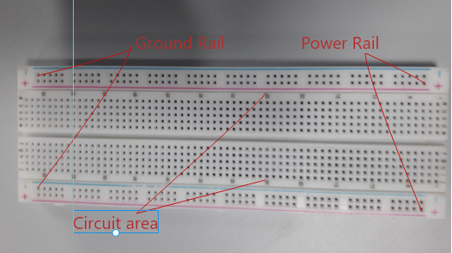

Figure 5: Breadboard

* *Jumper Wires (Both M-M and M-F)*

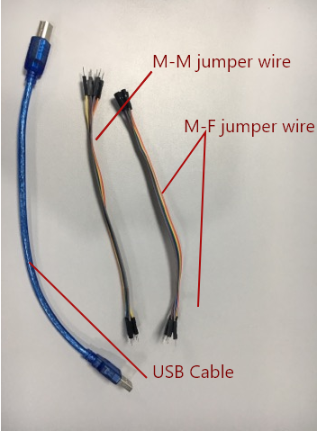

Figure 6: Jumper wires

* *Moisture Sensor*

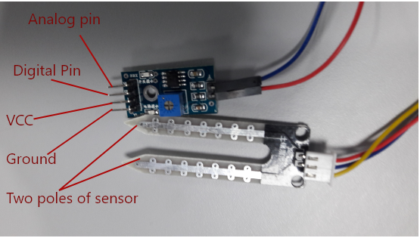

Figure 7: Soil Moisture Sensor

* *GSM Module*

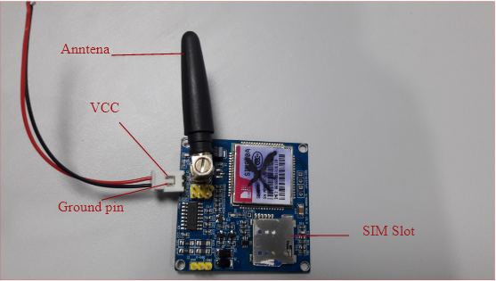

Figure 8: GSM module (SIM900A)

* *Bulb with its fitting holder*

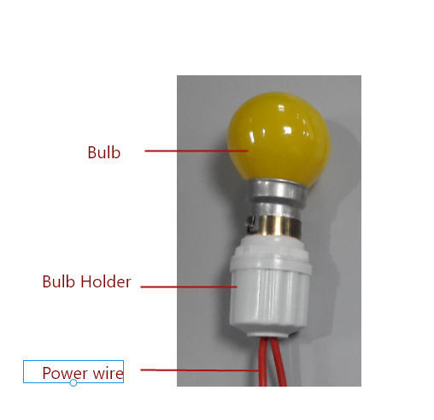

Figure 9: Bulb for Notification

* *Relay (Multiple)*

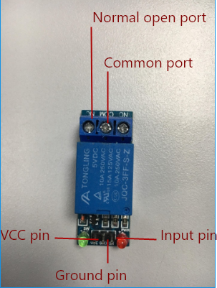

Figure 10: Relay

* *Water Motor (9v)*

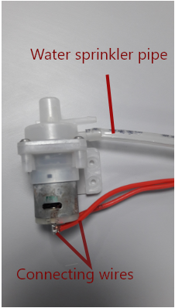

Figure 11: Water Motor

# How it works?

In the developed Automatic Irrigation System, Arduino as microcontroller, SIM900 as GSM module, Soil Moisture sensor for moisture value, 9v battery to power DC water motor, Relay as switch to open and close circuits, Light to notify the motor on, Breadboard and jumper wires for devices connection are used.

Working of this Automatic Irrigation system is quite simple. Here soil moisture sensor obtains the moisture value when small current is passed through it. A resistance value to measure the moisture value is acquired when two probes of sensor drives current through the soil. It depends on the water intensity in soil as soil conduct more electricity when soil have high moisture means less resistance. (Jojo, 2018) The digital value obtained is processed by microcontroller. When the moisture in soil is low then microcontroller puts both relays “ON”. When relay is on “ON” state both water motor on and Light will glow. At the same time microcontroller actives, the attached GSM module which will send message to individual’s cell phone. Here glowing red light will notify the motor is on locally and Message will notify wherever individual is. (Kirkebut, 2014)

Similarly, when moisture value detected will be high then microcontroller puts water motor OFF and light will be OFF. The GSM module is triggered which sends message to individual’s cell phone about the motor is OFF.

# The Build

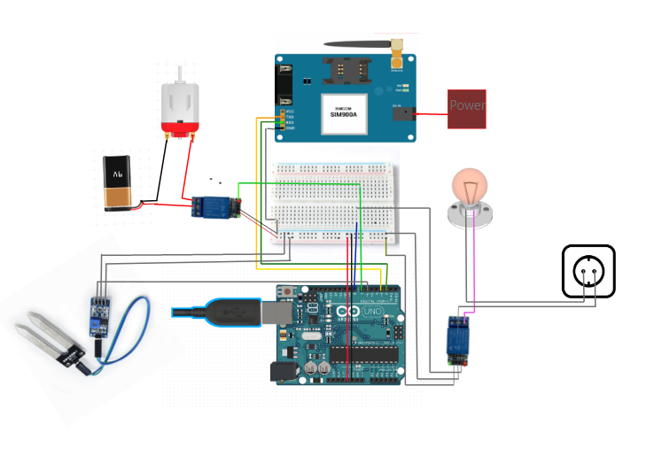

Figure 13: Circuit Diagram of system

Here Arduino Uno is used as microcontroller and make sure to download Arduino IDE first of all.

* Take Soil moisture sensor and connect its pin to microcontroller as below:

|  |  |
| --- | --- |
| VCC | 5V |
| GND | Ground pin (GND) |
| DO |  |

* Take Water motor and connect its one wire with relay (NO port) and another with direct battery. The Common port (COM) in relay is connected to another pole of batter. Here, 9v DC motor is taken where we have to provide power of 9v battery. The relay is then connected with microcontroller in pin as below:

|  |  |
| --- | --- |
| VCC | 5V |
| GND | Ground port (GND) |
| IN | To pin to control |

* As for delivering message notification, GSM module (SIM900A) is now connected to microcontroller where GND pin is connected with Ground pin and 5V power is supplied using VCC pin.
* Now for water motor on/off notification locally, light is controlled using relay. The VCC and GND port in relay is connected to 5V and GND at microcontroller respectively. The IN port is connected to microcontroller using M-F jumper wire.
* Breadboard was used to support these devices connection microcontroller. They have many rows and columns of conductive points for connecting device with controller using jumper wires.
* Lastly, two consecutive points of light wire are connected to direct AC current and the working model is ready.
* Once it is confirmed connected setup match with the circuit diagram provided below, upload the code and make sure to download library required in Arduino IDE. (Arduino, 2017)

# The Build

Arduino IDE is utilized for programming microcontroller. Here a variable moistueValue is used to store moisture value provided by sensor. Arduino pin 8 is connected to relay that controls light, pin 7 is used for connecting motor using relay and for sensor value pin 6 is used. If the moisture value in soil is high, microcontroller puts pin 7 and 8 in High state because both are controlled by relay (relay works right opposite) and the connected GSM module will be trigged where it sends message that the motor is OFF and vice versa.

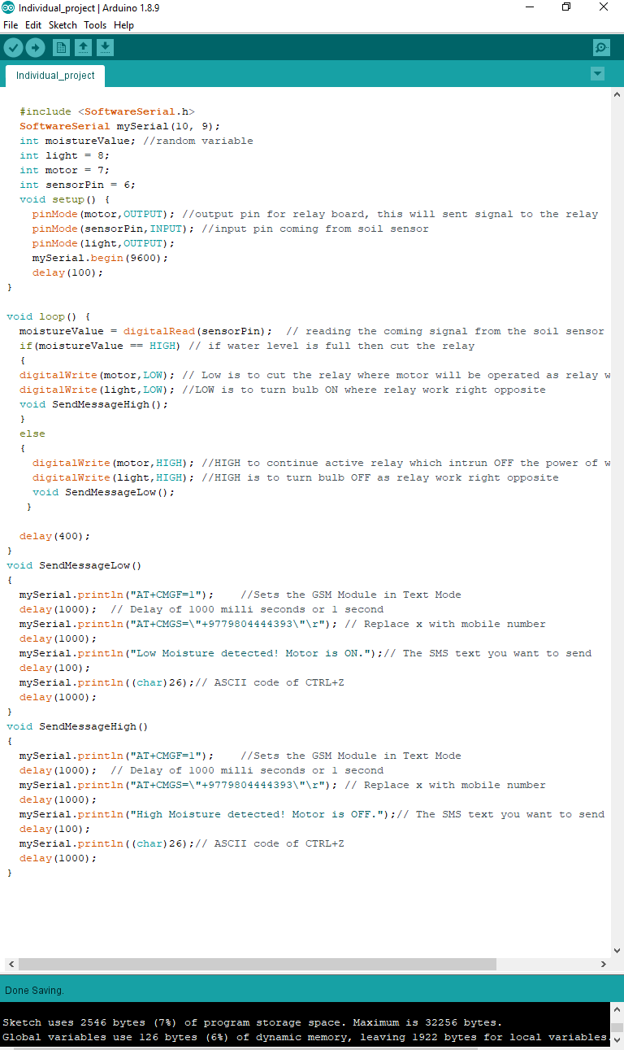

Figure 14: Code that is to be upload in microcontroller

# Troubleshooting

In case of any errors during the build, the following steps can assist in troubleshooting.

* There may be a condition when the soil moisture sensor may not cause the water motor to operate. During then, we can check if it is working or not by looking at the serial the serial motor.
* If there are values showing up, then we can check the connectivity of water motor.
* Similarly, if there is no notification on the user’s phone, we can double check the connectivity of the GSM module and the sim card inserted.

# Other Application

This is magnificent that the project developed can also be used at multiple locations like,

* *Household Water tank*

We can put the sensor at the lid of tank and when the water level touches sensor, the moisture value obtained will be high and controller can cut off the circuit of water motor and vice versa.

* Internal Planting/Lawn

This system is also suitable for small internal Lawn. This will help to increase greenery in your Lawn without any human interaction.

# Future Scope

We can add improvements in this project in near future. This future work will assist farmers and helps to grow more greener crops.

* We can add pesticides and fertilizers automatically in water as required.
* Other parameters such as humidity, temperature, light intensity can be measured which will additionally improve cultivating.
* The whole system can be powered using solar panels which will make system trouble-free to use in remote farm.
* An additional LCD screen can be added to the system which will provide all the sensor values and other data.
* Currently the system does not store any log information. We can add database that will store all data log which can be further processed to obtain different information.

(Dhore, 2017)

# Conclusion

Mostly farmers had to ruin their time watering their plants and manual watering usually waste high quantity of water. This project Automatic irrigation system will save farmers time and helps to save water at the same time. Sensor’s are to be deployed in different place of farms and those sensors will collecting moisture details and when the moisture decreases the threshold limits than microcontroller will active relay resulting the motor on and sprinkler will water the plant. All of the conclusion is farmer no longer spend their valuable time watering plant. This will help to grow plants in adequate use of water supply.